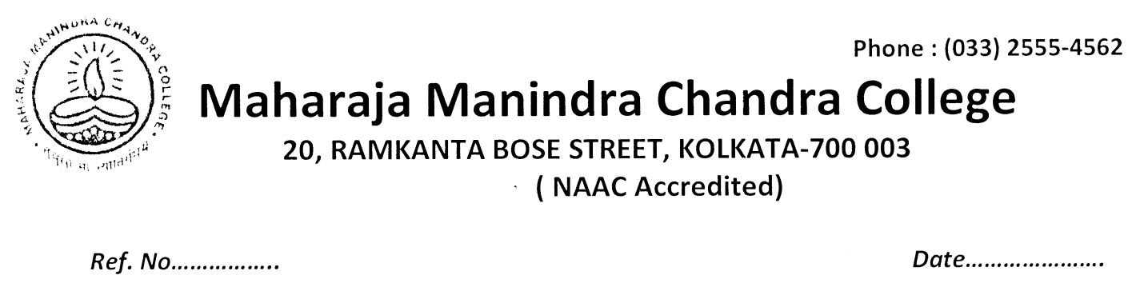
NOTICE
The tutorial examination of ECOA Hons CC1 : Introductory Microeconomics will be held online on 20th and 21st February , 6 pm onwards.

CC2:
Mathematical Methods in Economics-I will be held on 21 st February from 12:30 pm onwards.

Principal
M.M.C.College
Kolkata-3

